召集人：______________ 學生社群名稱Course：_________________
單據資料information |  | 商品照片Product photos | 發票照片Invoice photos
發票號碼Invoice number | JW70980116 | 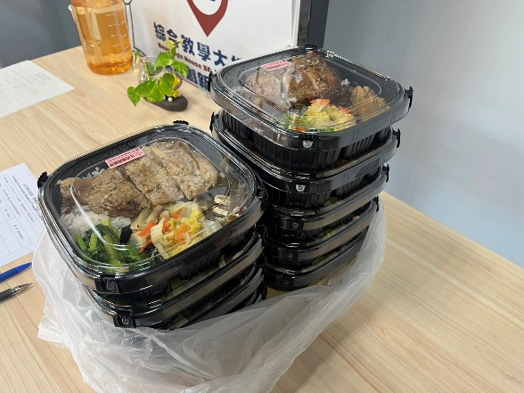  範 本 | 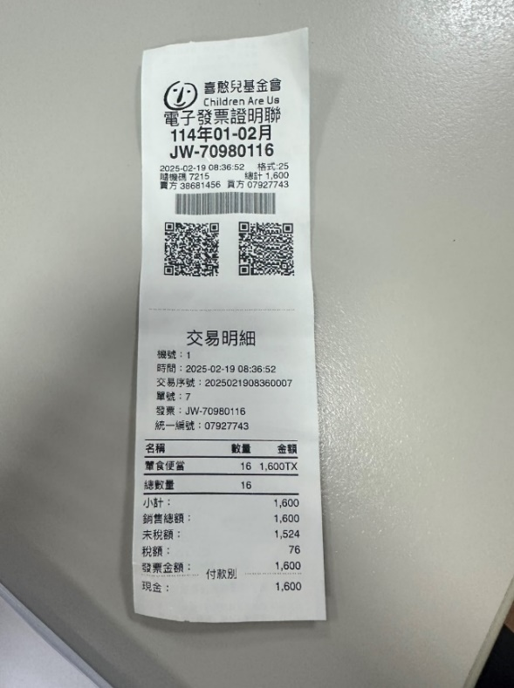  清楚的發票照片  A clear photo of the invoice.  範 本
品項Items | 膳食
金額Amount | 1,600
用途illustrate | 會議便當
發票號碼Invoice number
品項Items
金額Amount
用途illustrate
發票號碼Invoice number
品項Items
金額Amount
用途illustrate
發票號碼Invoice number
品項Items
金額Amount
用途illustrate

