教師姓名Teacher：______________ 新鮮人社群名稱Course：_________________
單據資料information |  | 商品照片Product photos | 發票照片Invoice photos
發票號碼Invoice number | KV25503089 | 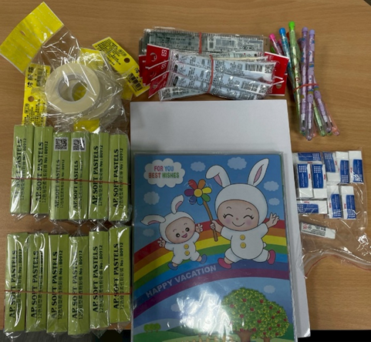  範 本 | 清楚的發票照片  範 本  A clear photo of the invoice.  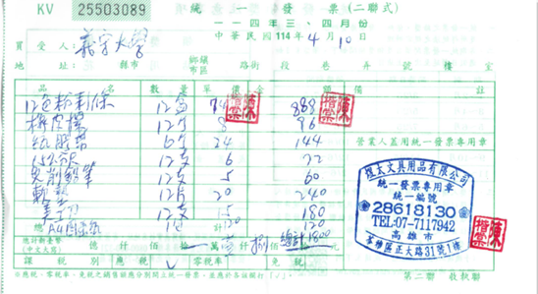
品項Items | 文具用品
金額Amount | 1,800
用途illustrate | 課程實作所需
發票號碼Invoice number
品項Items
金額Amount
用途illustrate
發票號碼Invoice number
品項Items
金額Amount
用途illustrate
發票號碼Invoice number
品項Items
金額Amount
用途illustrate

